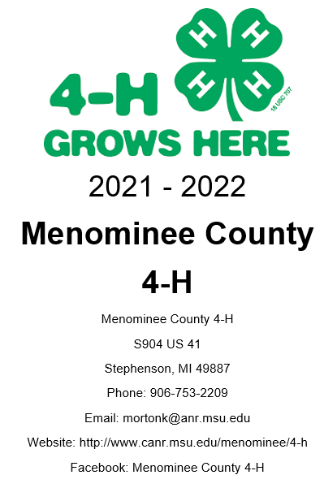
What is 4-H?
4-H is delivered by Cooperative Extension—a community of more than 100 public universities across the
nation that provides experiences where young people learn by doing. Kids complete hands-on projects in
areas like health, science, agriculture and citizenship, in a positive environment where they receive
guidance from adult volunteers and are encouraged to take on proactive leadership roles. Kids experience
4-H in every county in the country—through in-school and after-school programs, school and community
clubs and 4-H camps.
In 4-H, we believe in the power of young people. We see that every child has valuable strengths and real
influence to improve the world around us. We are America’s largest youth development organization—
empowering nearly six million young people across the U.S. with the skills to lead for a lifetime. 4-H is
also Michigan’s largest youth organization with over 200,000 members. Menominee County 4-H has
approximately 170 youth, 80 volunteers, and 19 clubs.
Interested in joining 4-H?
• Youth ages 5—19 can join! Ages are determined as of January 1. Youth ages 5—7 are Cloverbuds
and participate in non-competitive programming. You do not need to own an animal or live on a farm
to join 4-H! We have many clubs that focus on non-animal projects, such as sewing, traveling, crafts,
honeybees, and more.
• There is no cost to join in Menominee County! Some clubs and projects may have
additional fees.
• Adult volunteers can also join 4-H to give back and lend a hand! Volunteers are a critical part of the
success of 4-H—make a difference with positive youth development in our county by sharing your
skills! Contact the Menominee County Annex for more information on how to volunteer.
How do I join?
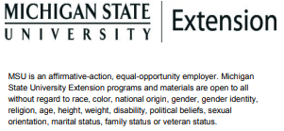
Find a club that meets your interests and contact the person listed to find out more information about
that club. Once you have selected a club, the administrative leader for the club will help you sign up!
Not sure where to go? Contact the Menominee County Annex and we can assist you!
 | Club Name | Contact Person | Primary Meeting Location | Main Project Areas | Ages
1 | 4-H Rockin’ Arts Club | Julie Simmons | Menominee | Arts & Crafts, Sewing | 8+
2 | A.C.E. (American Citizenship Experience) | Donna Buechler | Daggett | Traveling | 7th grade and ↑
3 | Bunny Bunch | Mandy Baumler | Daggett | Rabbits, Guinea Pigs | 9+
4 | Misfits 4-H Club | Sonja Popour | Powers | Lambs | 8+
5 | Hogs-R-Us | Lindsey Borski & Brianna Hess | Stephenson | Hogs | 8+
6 | Knee Deep in The Barnyard | Nikki Tebo | Stephenson | Lambs, Goats, Swine | 8+
7 | Looking Good | Sheryl Schrot | Stephenson | Sewing, Arts & Crafts, Cooking | 4th grade and ↑
8 | Youth Council | Kris Havelka | Stephenson | Leadership, Community Service | 12+
9 | Mid-County Beef | Nina DeLaurelle | Daggett | Beef | 9+
10 | Midnight Riders | Julianne Freis & Brianna Hess | Stephenson | Horses, Arts & Crafts | 5+
12 | Crafty Buds | Lynda Putnam | Stephenson | Arts & Crafts | 5-7
13 | Crafty Critters | Haili Thoney | Stephenson | Beef | 9+
14 | Dare to Dream Riders | Sandy Gill | Menominee | Horses | 11+
15 | Kids & Critters | April Behnke | Stephenson | Dairy | 5+
16 | Growing Gardens Together | Sue Stanley | Stephenson | Gardening | 6+

